AWS Tutorial: AWS SageMaker

Time spent: 60 min

Amazon Overview

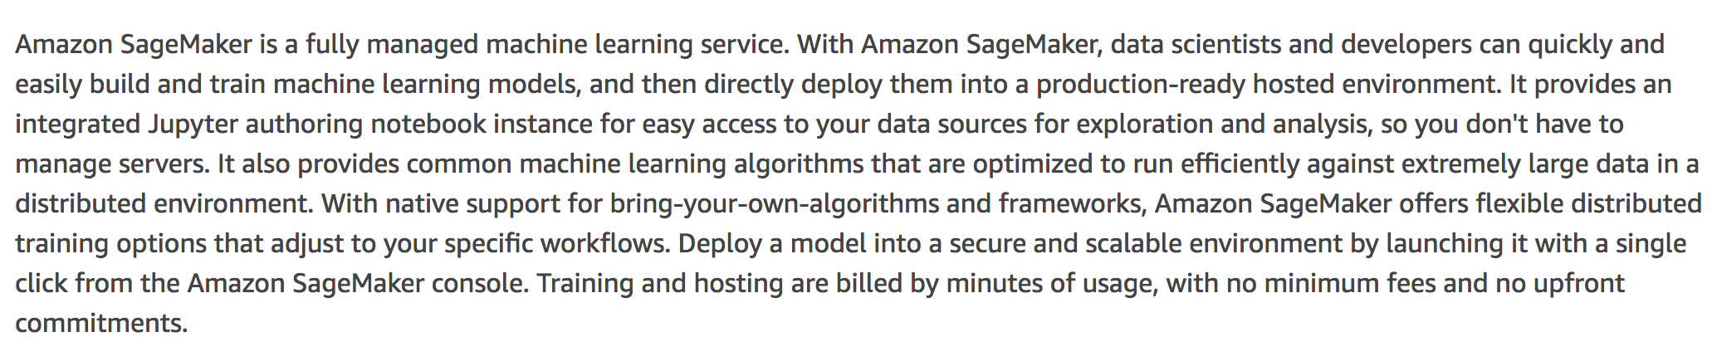 – From AWS document

What I learned

* What is Amazon SageMaker
* How to create the notebook to operate the instance
* How to do the training job by high-level Python library
* Related components: AWS SageMaker, S3, jupyer

What I built

* Create the SageMaker instance

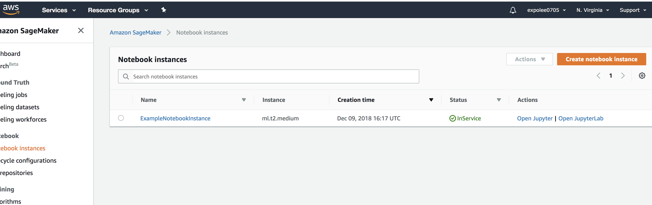

* Create the notebook to operate the instance to train the data

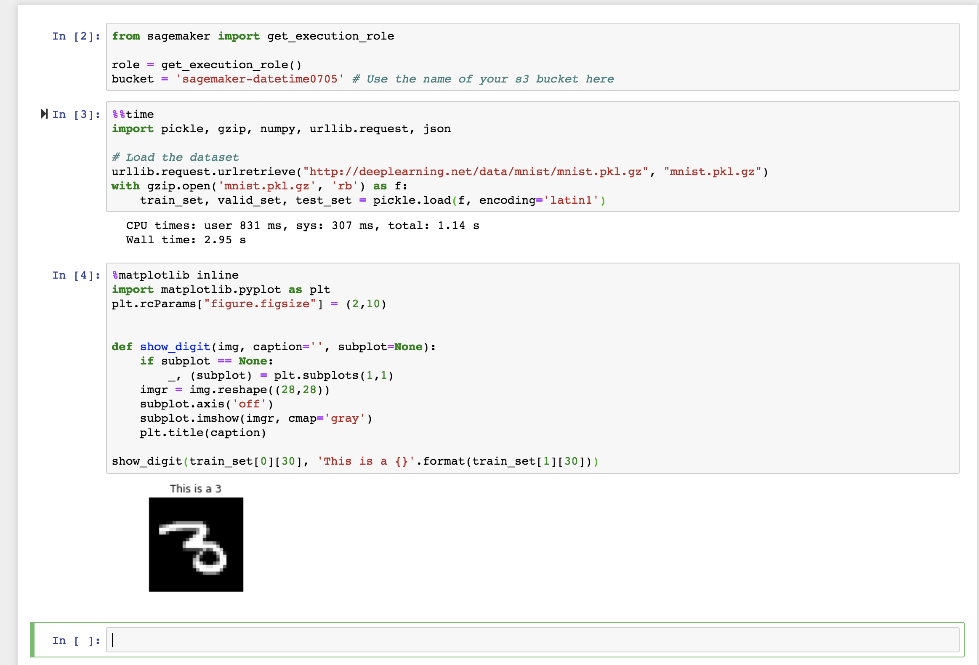

* Deploy and validate the model

